**Lab 8 Modeling Relational Database and ARCs (pts.3)**

**Submission requirements:**

1. Use any software to draw ERD if there is any.
2. Take screen capture or capture of hardcopy of the data model and embed it in the document.
3. Resave the document with your name_lab#_db. (E.g yourname_lab2_db)
4. SUBMIT ONLY WORD DOCUMENT OR PDF.
5. Submit it in the link provided in assignment section.

1. Examine the sample data in the following tables. Check for entity, referential, and column integrity. Identify any data-integrity violations. Assume that all date columns should have a date format and all amount columns should have a number format. (pts 1.5)

1. For each table in the database, identify the primary key and the forein key(s). If a table does not have a foreign key, wrIte None in the assigned space.

|  |  |  |
| --- | --- | --- |
| **Table** | **Primary Key** | **Foreign Key** |
| **INVOICE** | **INV_NUM** |  |
| **PRODUCT_INVOICED** | PROD_NUM, INV_NUM | PROD_NUM, INV_NUM |
| **PRODUCT** | PROD_NUM |  |

1. Do the table exhibit entity integrity , column integrity and referential integrity? Answer Yes or No, then explain your answer with examples.

|  |  |  |
| --- | --- | --- |
| **Table** | **Entity Integrity Key** | **Justify your answer** |
| **INVOICE** | YES | Column exhibits integrity because there are no null fields and all the keys are unique. |
| **PRODUCT_INVOICED** | YES | Table exhibits integrity because there are no null fields and all the compound keys are unique. |
| **PRODUCT** | NO | There are duplicate primary keys (GH-U34JR4). |

|  |  |  |
| --- | --- | --- |
| **Table** | **Column Integrity** | **Justify your answer** |
| **INVOICE** | **YES** | All columns contain values consistent with a definied data type. |
| **PRODUCT_INVOICED** | **YES** | All columns contain values consistent with a defined data type. |
| **PRODUCT** | **NO** | One column contains values inconsistent with a definied data type (PROD_LABEL). |

1. Do the tables exhibit referential integrity? Answer Yes or No, then explain your answer with examples. Write NA(Not Applicable) if the table does not have a foreign key.

|  |  |  |
| --- | --- | --- |
| **Table** | **Referential Integrity** | **Justify your answer** |
| **INVOICE** | Null | Contains no foreign keys. |
| **PRODUCT_INVOICED** | NO | One foreign key does not match with an existing primary key value (BG-4564B5. |
| **PRODUCT** | Null | Contains no foreign keys. |

1. Draw the ERD with the entities given in Question 1.(.5)

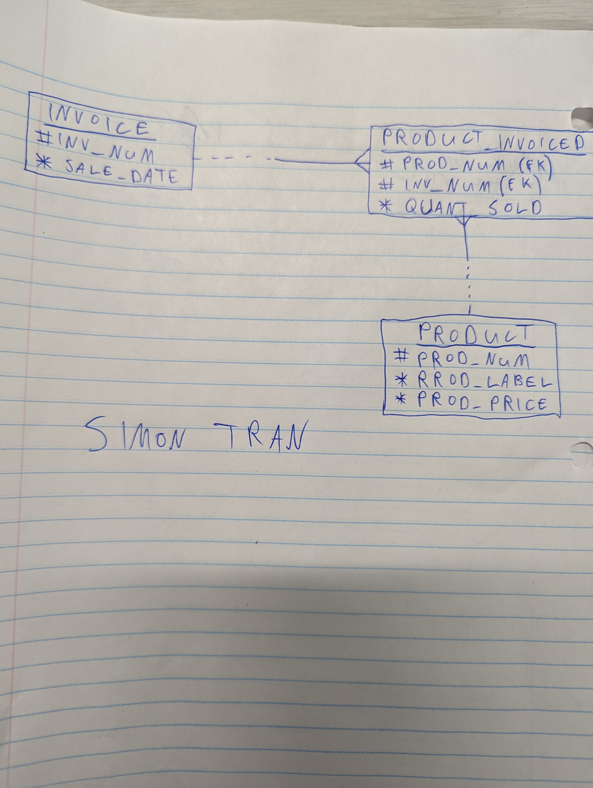

1. A Test is scheduled in the Testing Centre or in the Class room. A Test has a number, date and weight. The Testing Centre is known by Centre_Id, opening_time, closing_time, name and a phone number and contact_person. The Classroom is known by room#, floor#, capacity. Draw the entities and represent the exclusive OR relationship (ARC). (pts 1)

